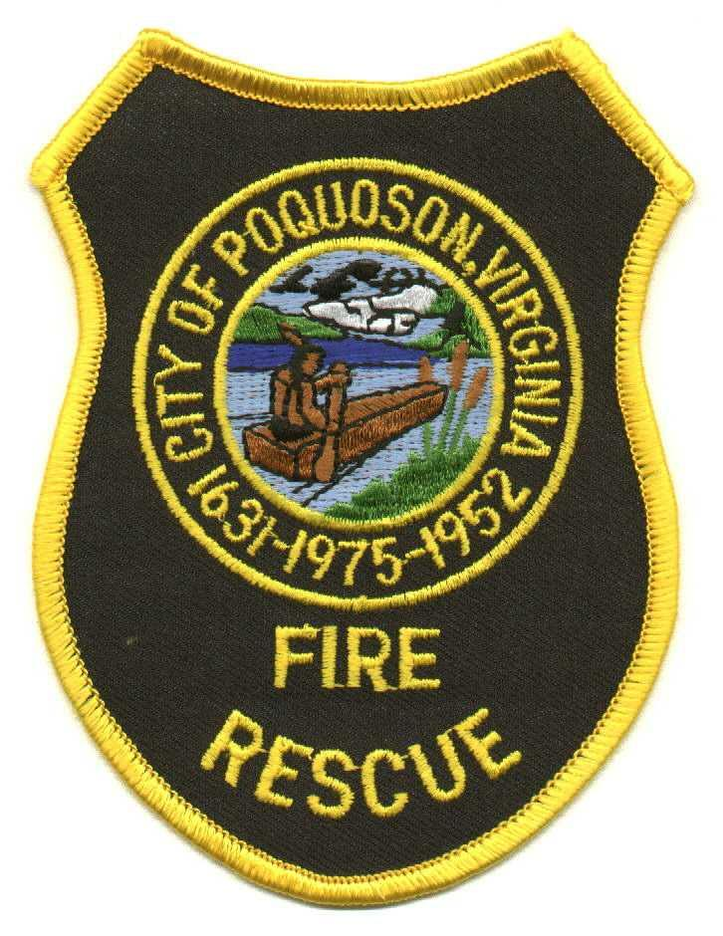

City of Poquoson Fire/Rescue
830 Poquoson Avenue, Poquoson, Virginia 23662 (757) 868-3510 Fax (757) 868-3514

Summary

- This is a new policy for the department to enhance our Health and Safety practices.

- Guidance is offered to recognize when Decontamination is warranted and how the process should be set up.

- Guidance is also offered to separate dirty gear from the vehicle’s cab to prevent contamination of the vehicle itself.

- Encouragement is offered to ensure staff continue to decontaminate once back at the station and outlines how to stagger crews to decontaminate while others are available for additional emergency response.

- Addresses Fire Investigators and the need to decontaminate following their investigation using the same process as Firefighters.

